Remote Controlled Maze runner(30/01/2026)
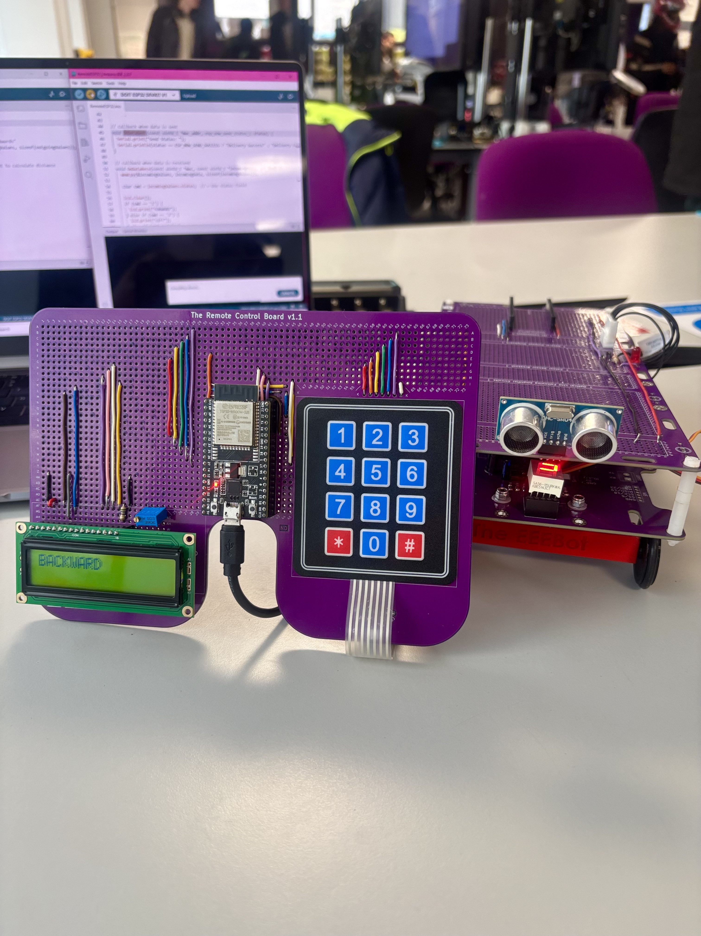
The Logical Voltmeter (Week 3)
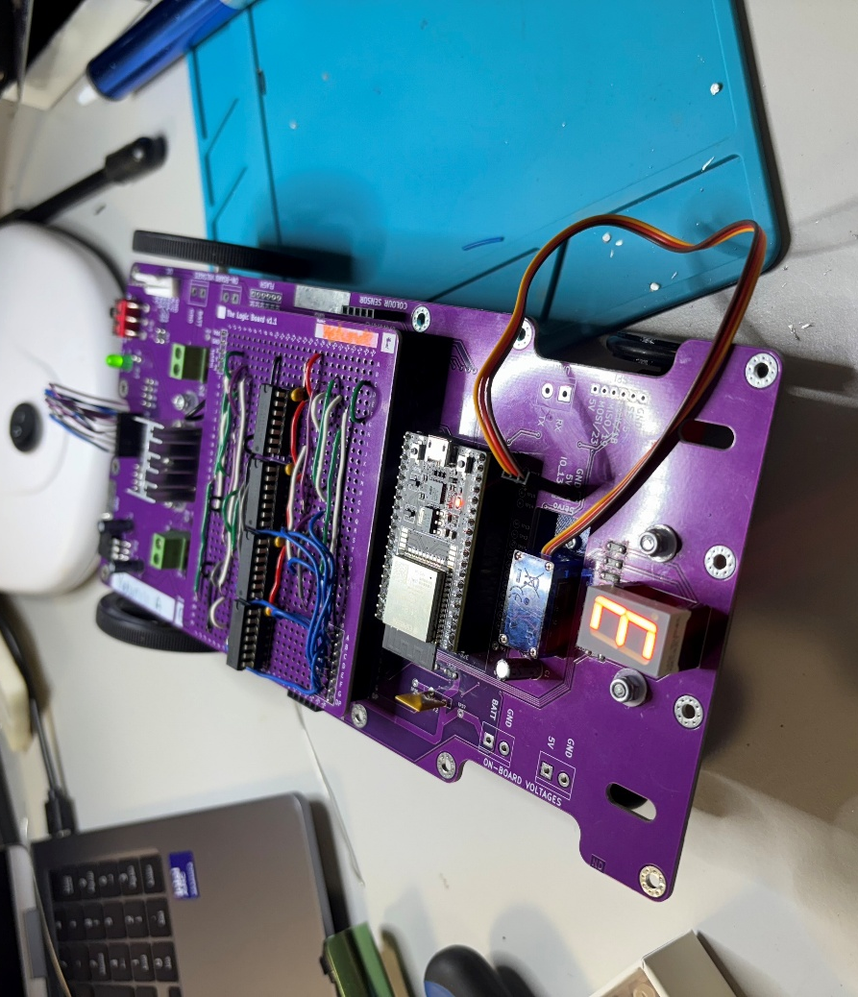

Maze Runner (Week 4)
